|  |  |
| --- | --- |
| **NAME** | ARNIKA K |
| **REGISTERNUMBER** | 812620104011 |
| **NMID** | 2DB62E83E5DA7B88DE74AEC740C351E9 |
|  |  |
| **ASSIGNMENT-2** | |

UploadthedatasettoCognosAnalytics,preparethedata,exploreandCreateInteractiveDashboard,Report andStory.

**Task**

**ProblemStatement:-**

TheCognosHRScorecard:MeasuringSuccessinTalentManagement.

HR data can be hard to come by, and HR professionals generally lag behind with respectto analytics and data visualization competency. We use the data set to teach HR students show touse andanalyze the datainCognos-adata visualizationtoolthat'seasytolearn.

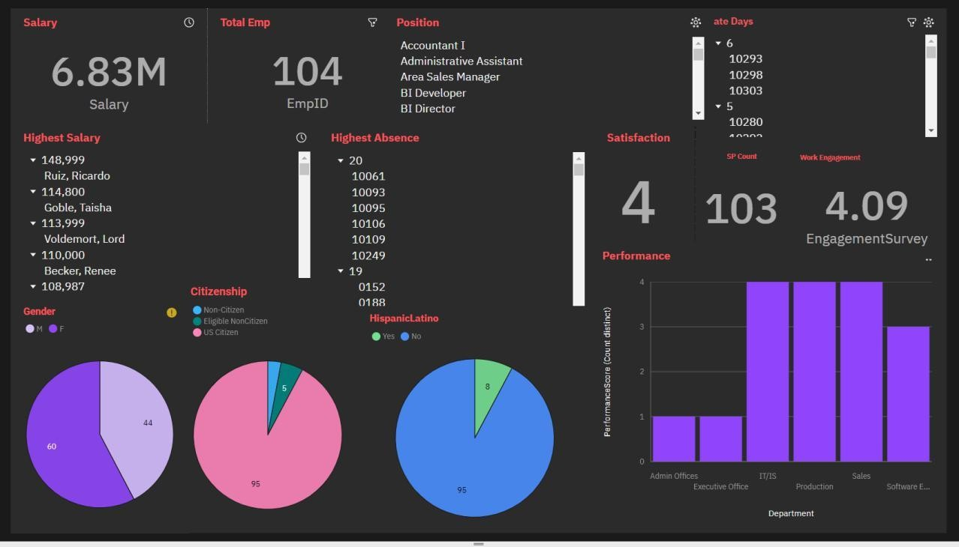**OverallDashboard**

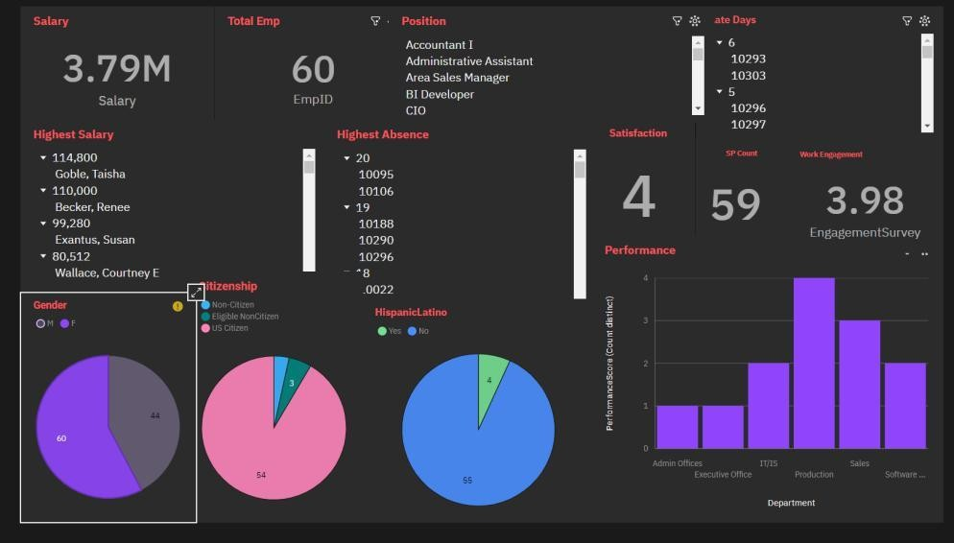**FemaleEmployees**

**MaleEmployees**

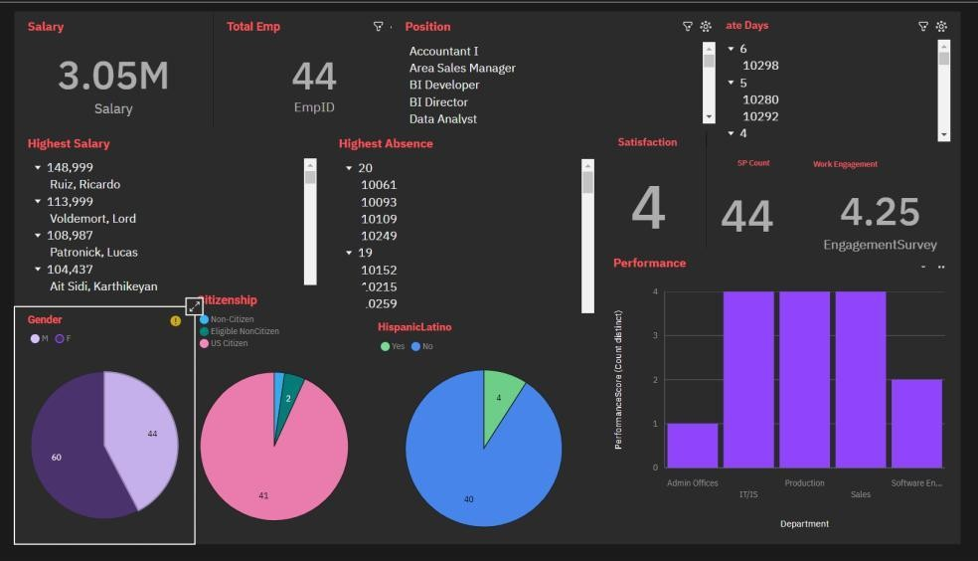

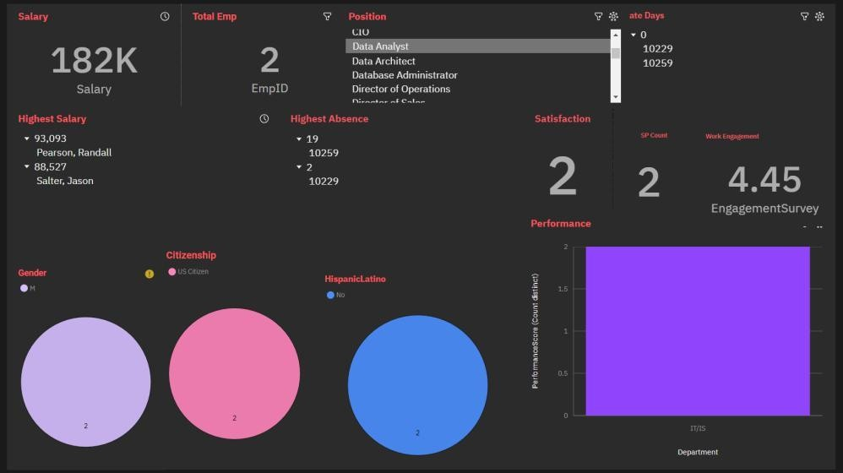**DataAnalystEmployee**

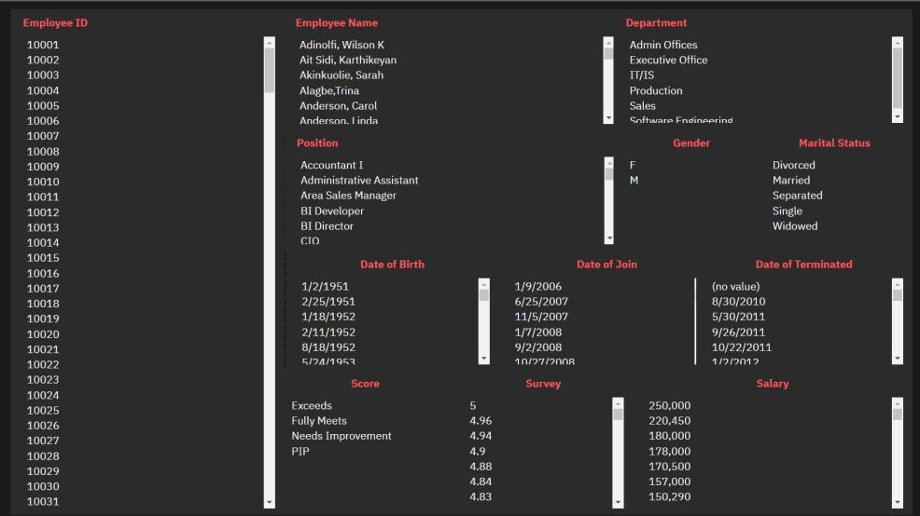**SearchDashboard**

**SearchwithEmployee ID**

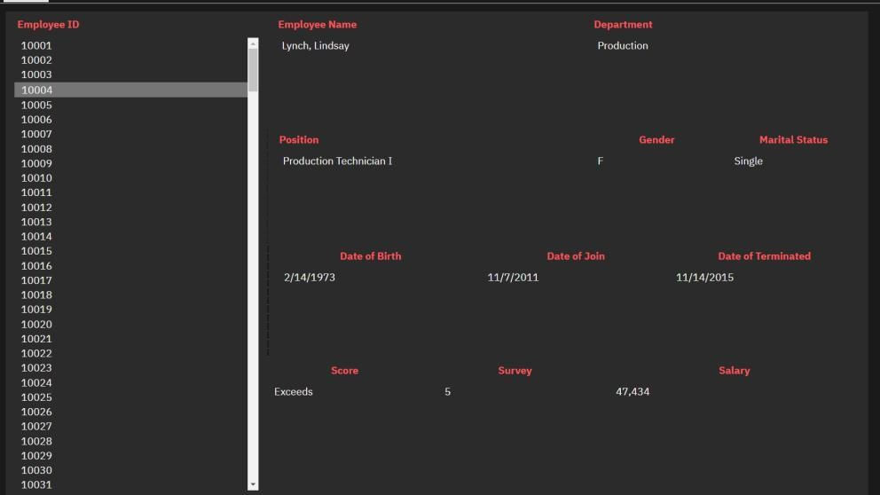

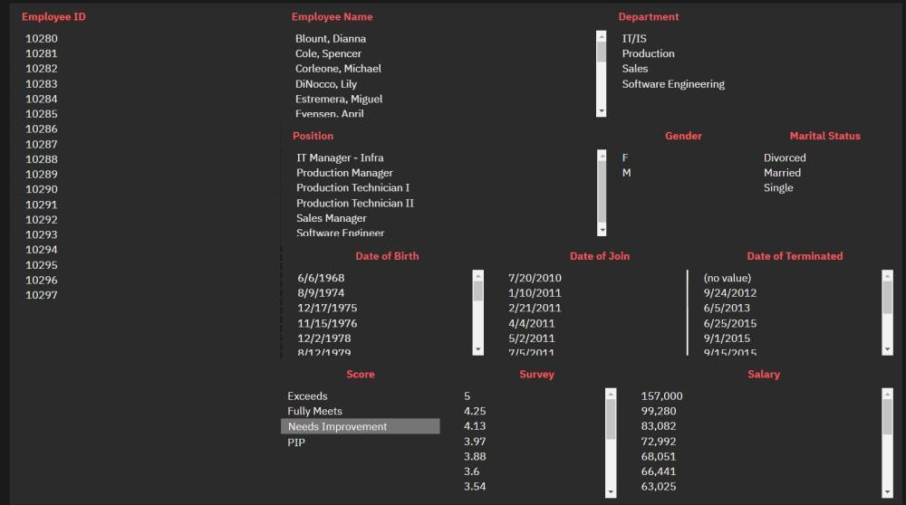**Search withPerformanceScore**